WildWind HOA Mailbox Guidance
As a reminder, all homeowners within the Wild Wind HOA are required to use the designated mailbox type when replacing or updating your mailboxes.
The approved mailbox design ensures uniformity and compliance with the community standards outlined in our WWHOA mailbox guidelines. If you experience any difficulties in obtaining the specified mailbox, please do not hesitate to contact WWHOA Email: wildwindhoa@gmail.com We are here to support you in adhering to these guidelines.

Thank you for your cooperation in maintaining the aesthetic and standards of our community.

Postal Pro- Craftsman mailbox and post kit in black.
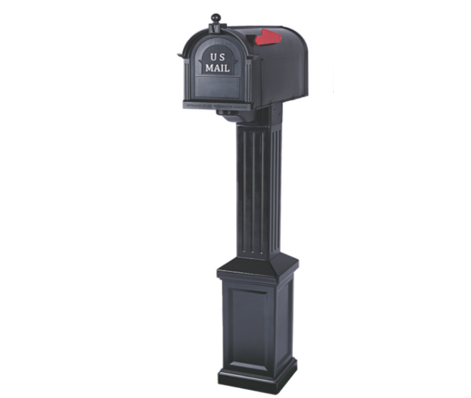
PP3400BLM – Craftsman Mailbox and Post Kit
The Craftsman Mailbox & Post Kit - Postal Pro
Postal PRO Craftsman Mailbox and Post Kit, Black PP3400BLM - The Home Depot

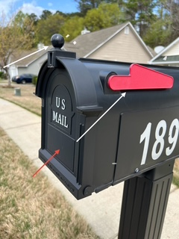
Additionally, if you ever need replacement parts for your mailbox—such as the red flag, door knob, or similar components—please refer to the contact information provided below for assistance:
Creative Solutions, LLC
Phone: 877-544-5220
Customer Service: customerservice@creativesolutionscp.com

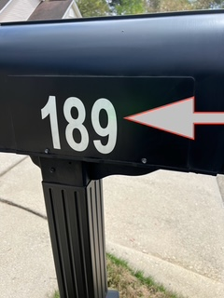
For mailbox numbers, please use 4-inch white reflective numbers as shown, which can be purchased at multiple retailers.

Please be advised that the WWHOA does not perform repairs and does not employ or retain a contractor for such purposes. However, as a courtesy, we are able to provide referrals to contractors upon request.
Mailbox Replacement – Contractor Referral
Tracey Isbell was the contractor used for the recent mailbox installations in our subdivision. He operates his own independent handyman business and is not affiliated with the WWHOA. This referral is offered as a courtesy; homeowners are encouraged to use their own judgment when deciding to contact or hire him.
Please note that Tracey Isbell is an independent contractor. The WWHOA does not endorse or assume responsibility for his services, pricing, or any agreements made. All arrangements and transactions are strictly between you, the homeowner, and Mr. Isbell.
You are also welcome to research and hire any contractor of your choice. We recommend exercising due diligence to ensure a successful outcome.
Contact Information for Tracey Isbell 📧 Preferred Contact: wwhoalights@gmail.com 📞 Phone: 678-447-7171 (Email is the most reliable way to reach him)
Thank you for your understanding and cooperation in this matter. Should you have any questions or require a referral, please do not hesitate to contact the WWHOA
Email: wildwindhoa@gmail.com

