WildWind HOA Front Yard Light Fixture Guidance
To ensure uniformity and uphold the aesthetic standards of our community, we would like to remind you that the following materials must be used when repairing or replacing exterior front yard light fixtures.
If you experience any difficulties in obtaining these fixtures or require further assistance, please do not hesitate to contact WWHOA Email: wildwindhoa@gmail.com We are here to support you in adhering to these guidelines.
Thank you for your understanding and cooperation in maintaining the beauty and harmony of our neighborhood.

Westmoreland 2300 – Post Mount
(Electric- Dual Inverted Candelabra or Nat. Gas - Dual Inverted Mantle)
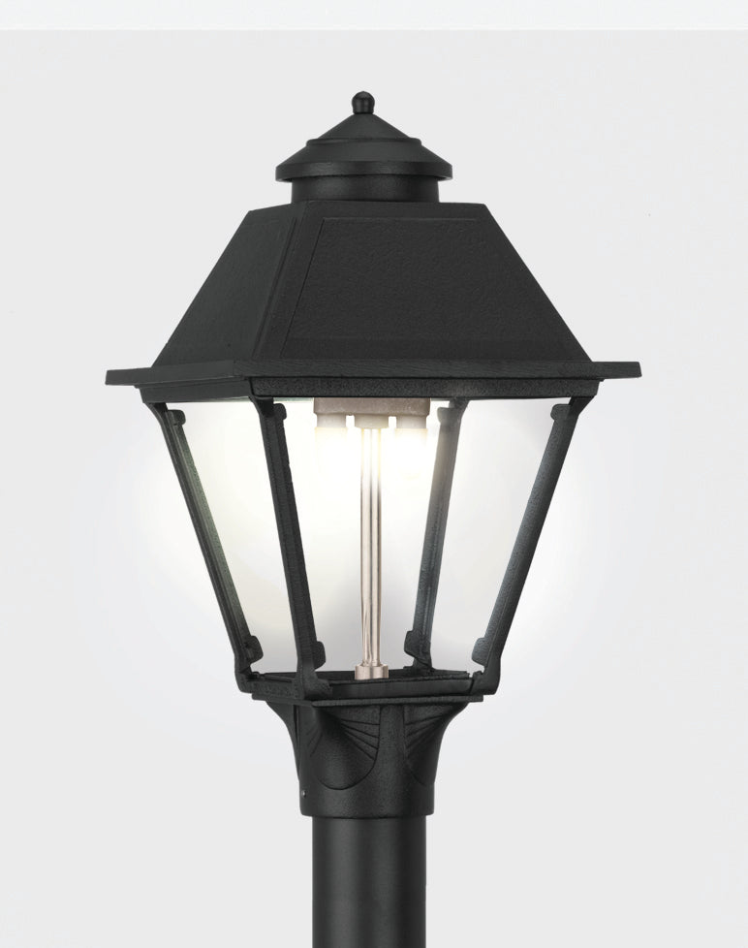
The Westmoreland 2300H Post Mount Gaslight by American Gas Lamp Works | Gaslights.com

The Westmoreland Post Mount Gas Light - 2300H – CunninghamLiving.com

The Westmoreland Outdoor Coach Lighting | American Gas Lamp Works
7' 9" black pole with ladder rest
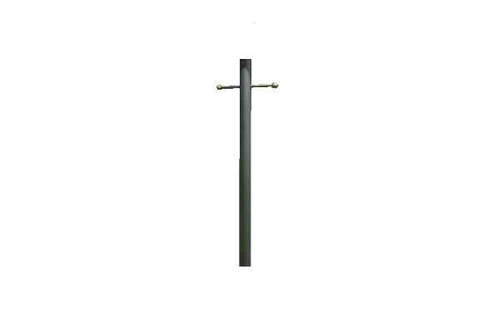
AGLW - 7'9" Steel Gaslight Post with Ladder Rest - P79L | Gaslights.com
Progress Lighting Outdoor 7' Matte Black Aluminum Post with Ladder Rest P5391-31 - The Home Depot
Black Plastic Ladder Rest Kit w/ Black balls
AGLW - Black Plastic Gaslight Ladder Rest w/ Black Balls - LR1BB | Gaslights.com
Black Gaslight Ladder Rest with Black Balls LR1BB – CunninghamLiving.com

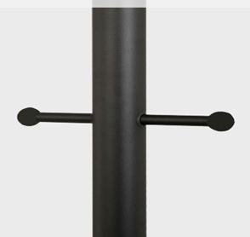
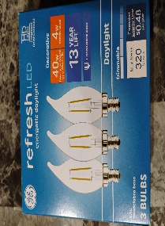
Soft Gaslight Mantles for Gas Lanterns.
2 Pack of Soft Gaslight Mantles - SM4 – Gaslights.com
Always follow the manufacturer's instructions! when handling gas mantels, and if you're ever unsure, it's best to consult a professional. Below are a couple of YouTube videos that provide a brief overview of how to change or replace gas mantels safely and effectively.
How to Replace Your Gas Lantern Mantles
Changing gas lamp mantle socks.
Light bulbs for Electric lanterns Candelabra base, 40w daylight, these were purchased at Lowe’s but can be purchased at multiple retailers.
GE Refresh 40-Watt EQ CA11 Daylight Candelabra Base (e-12) Dimmable LED Decorative Light Bulb (3-Pack) 93122338 at Lowes.com

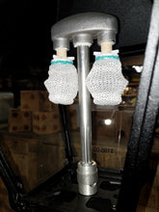
We're excited to offer you an exclusive discount! Use coupon code GasLights2025 at checkout on the website www.gaslights.com to enjoy special savings on your next purchase.
Please be advised that the WWHOA does not perform repairs and does not employ or retain a contractor for such purposes. However, as a courtesy, we are able to provide referrals to contractors upon request.
Front Light Repair & Conversion – Contractor Referral
Tracey Isbell has assisted many homeowners in the subdivision with front light repairs and conversions. He operates his own independent handyman business and is not affiliated with the WWHOA. This referral is offered as a courtesy; homeowners are encouraged to use their own judgment when deciding to contact or hire him.
Please note that Tracey Isbell is an independent contractor. The WWHOA does not endorse or assume responsibility for his services, pricing, or any agreements made. All arrangements and transactions are strictly between you, the homeowner, and Mr. Isbell.
You are also welcome to research and hire any contractor of your choice. We recommend exercising due diligence to ensure a successful outcome.
Contact Information for Tracey Isbell 📧 Preferred Contact: wwhoalights@gmail.com 📞 Phone: 678-447-7171 (Email is the most reliable way to reach him)

Thank you for your understanding and cooperation in this matter. Should you have any questions, please do not hesitate to contact the WWHOA
Email: wildwindhoa@gmail.com

